Steps to perform AzureADListRolesUser Key Rotation Activity

The following document lists down steps to perform key rotation activity for the IAM user AzureADListRolesUSer which is created in an AWS account, so as to facilitate the creation of new Azure AD Group based on the new role created by user.

1. Login to AWS Account <https://myapps.microsoft.com/signin/113614_222000900240_ACP_AWS_APP/8b9d9899-ab55-48ea-adfd-2f28bb9ea5a5?tenantId=e0793d39-0939-496d-b129-198edd916feb>  
     
   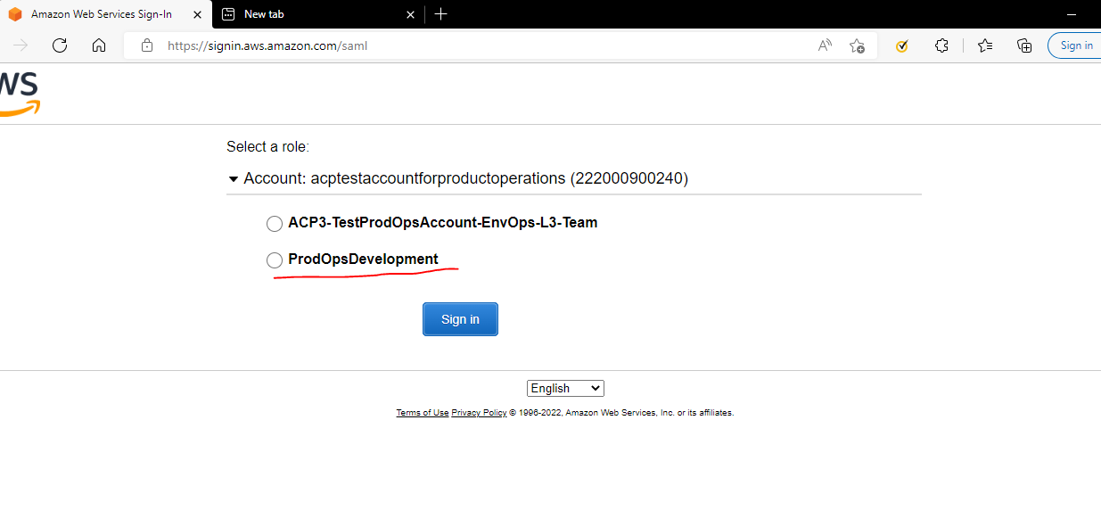
2. Switch to Ohio region and open CodeCommit service
3. Click on repositories from left navigation pane under Source and click on Cloudcontrol repositories   
     
   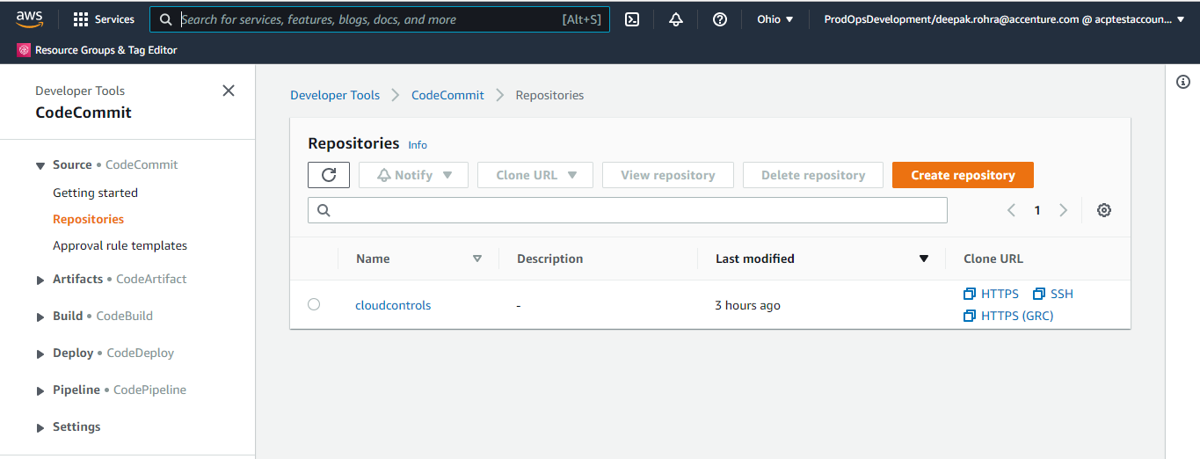
4. Select branches and click on create branch and select Branch From as “Master”

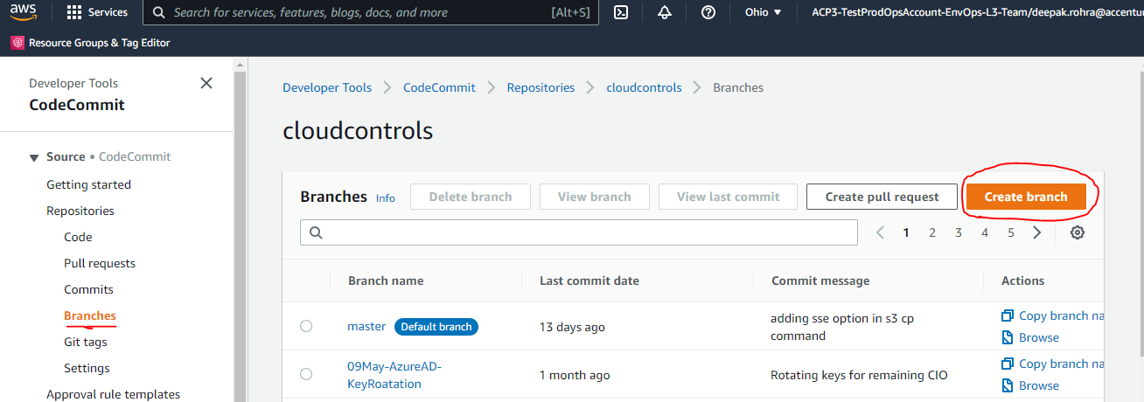  
  
  
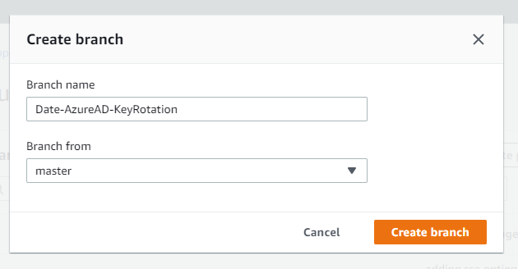

1. Open the directories as per following path cloudcontrols/onboardAWSAccount/setup/ADFStoAADMigration_v2/  
     
   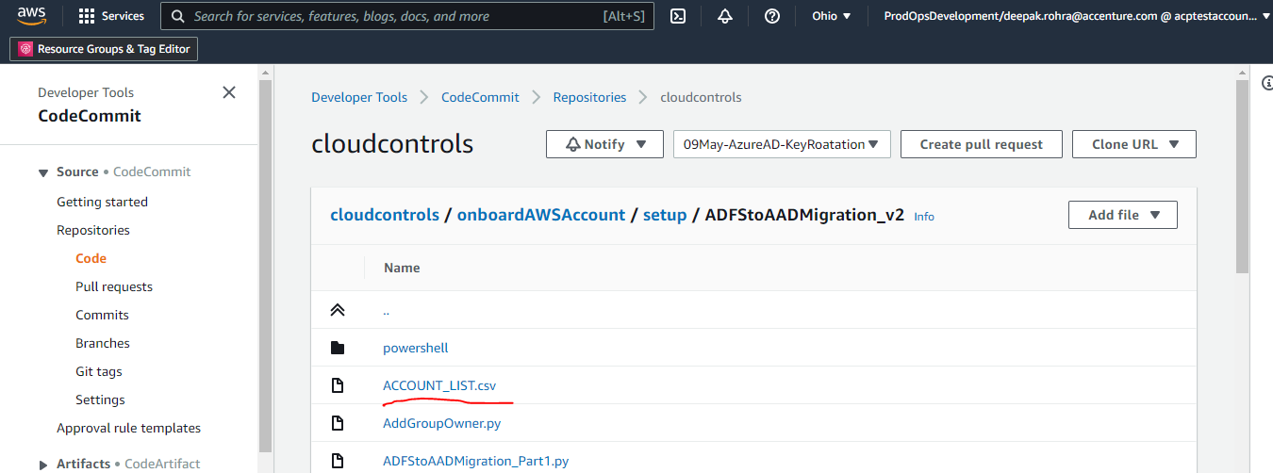
2. Click on Edit under Account_list.csv file to update the list of accounts for which keys needs to be rotated.   
     
   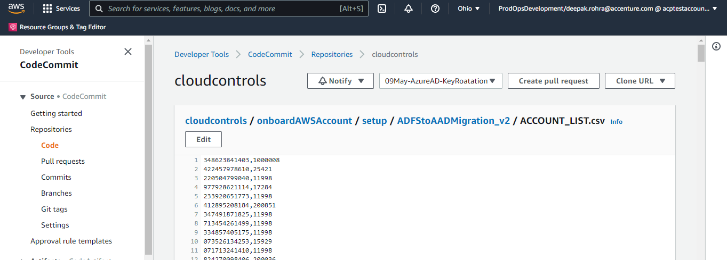
3. After updating the list fill in your name as Author and email ID and click on commit changes   
     
   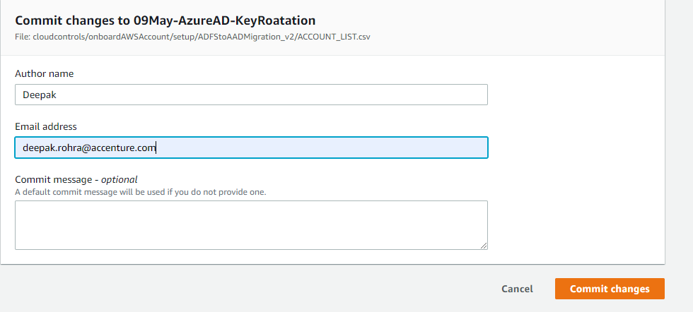
4. After committing the changes click on create pull request   
     
   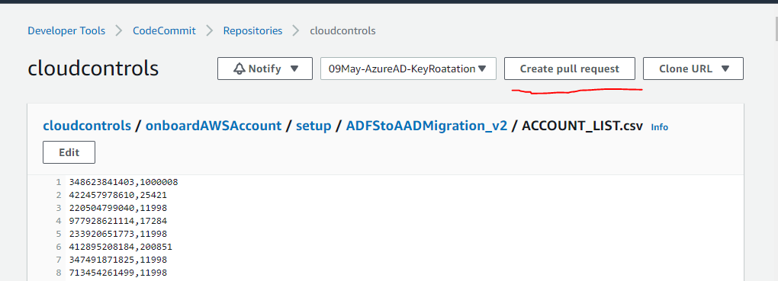
5. Fill in title as date_keyrotation and click on create pull request  
     
   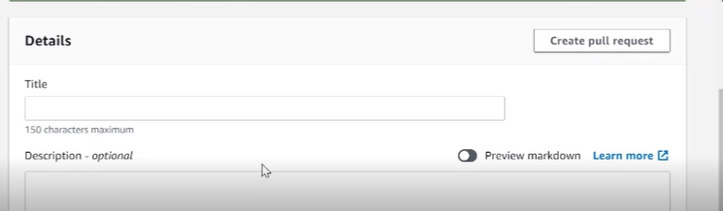
6. The request would then needs to be approved by other individual with ProdOpsDevelopment role. Approver would find the request under Pull requests section.  
     
   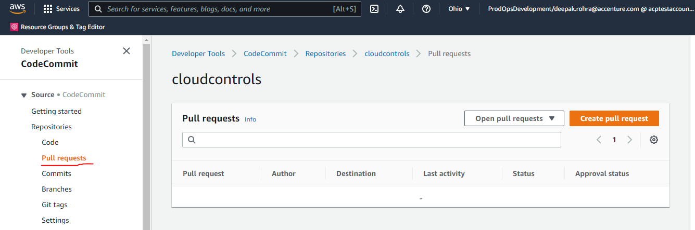
7. Once the request is approved the execution would get triggered automatically.
8. To check the status of Failed and Success Accounts, login to Bastian Host and open the following path  
     
    ***C:\ProgramData\Amazon\CodeDeploy\6fa66c5e-f711-45d7-8e0e-cc39097ebe27\***
9. Under this path a new folder would be created (can be checked based on the date) and under that folder you can further follow the path below.  
      
   ***deployment-archive\onboardAWSAccount\setup\ADFStoAADMigration_v2***  
     
     
   